**Managing Access Control for Storage in AWS**

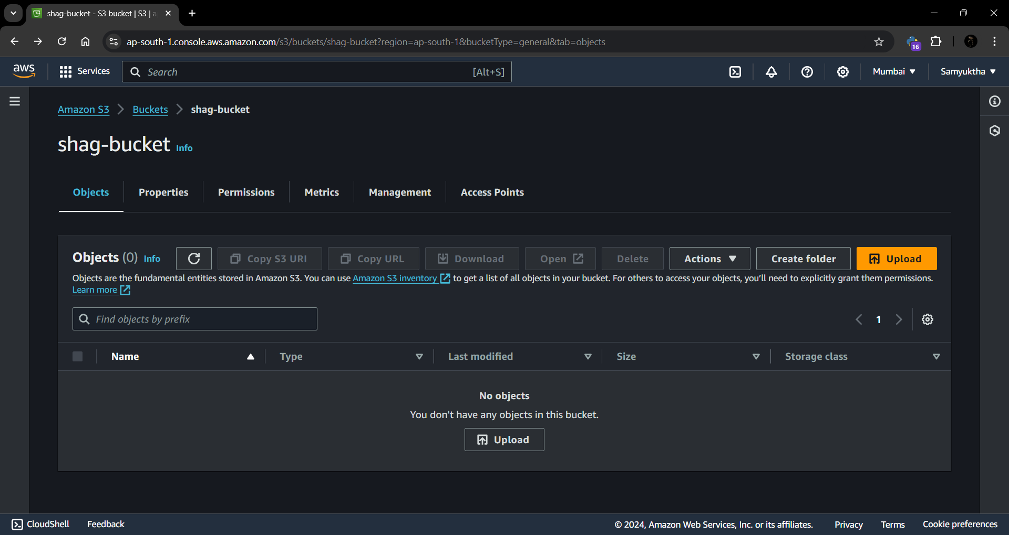

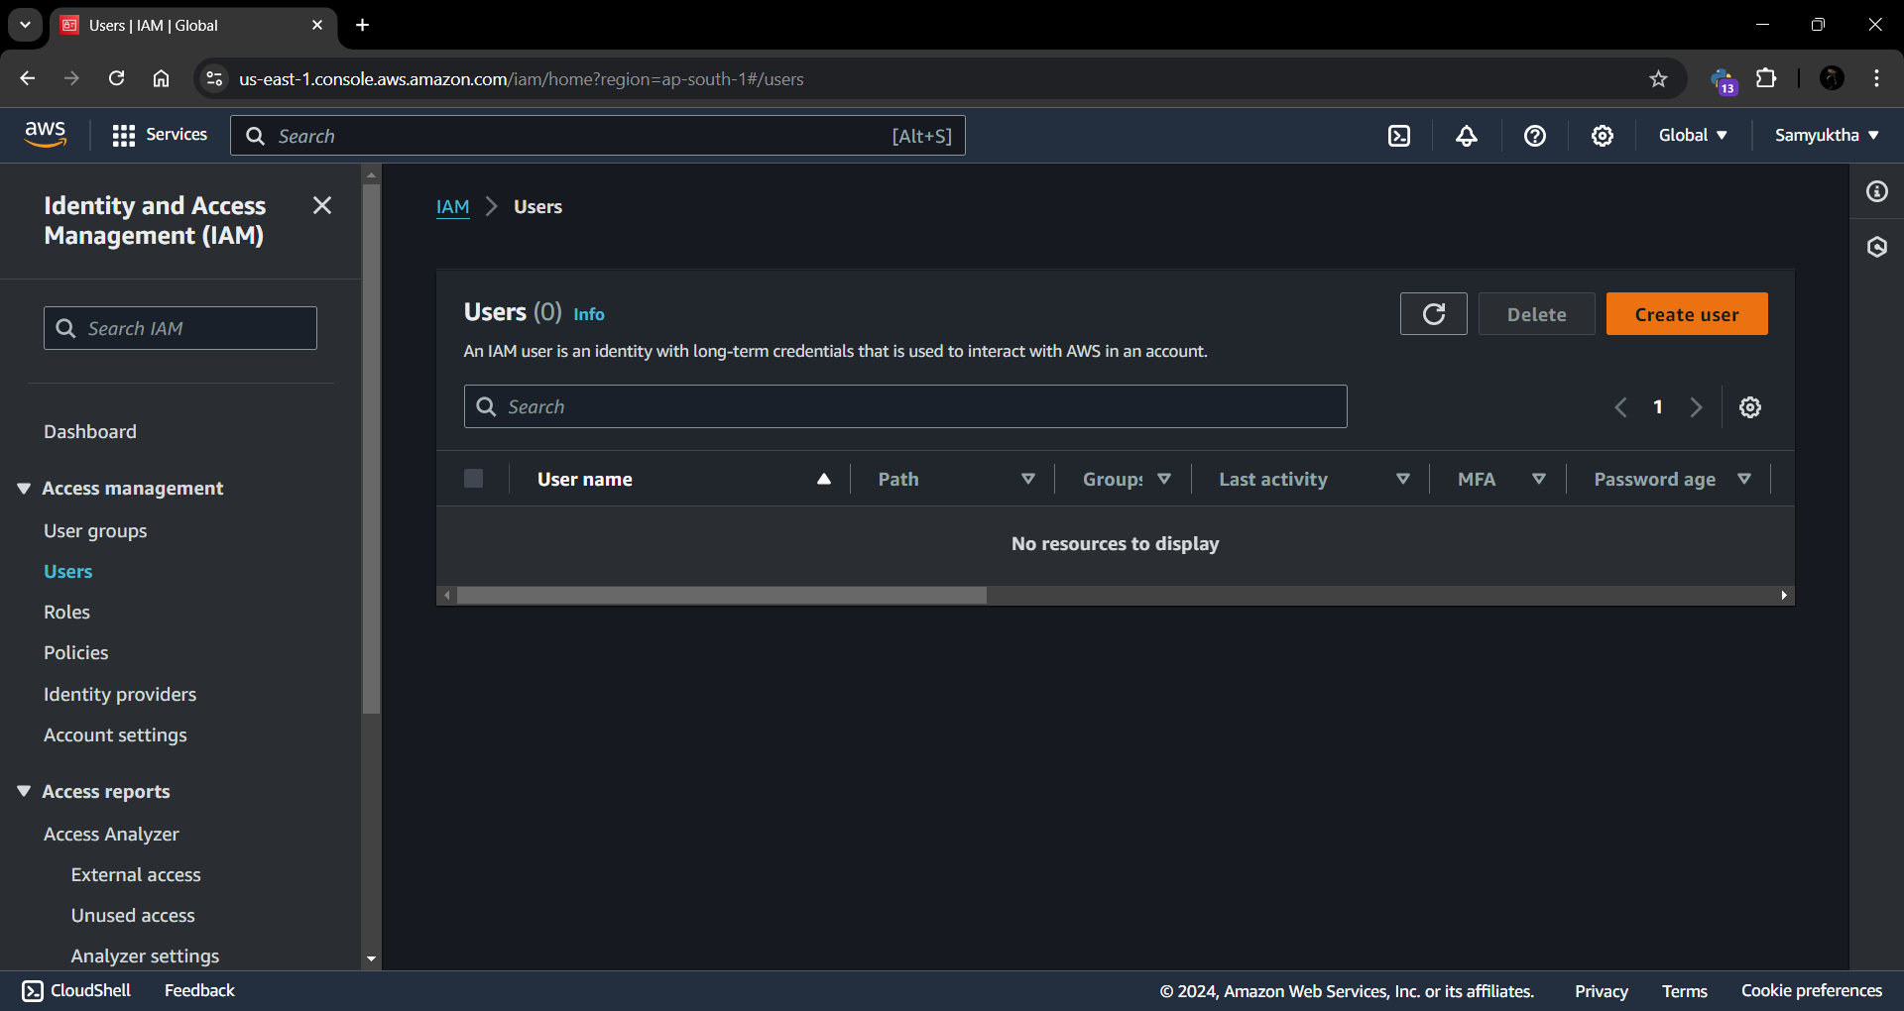

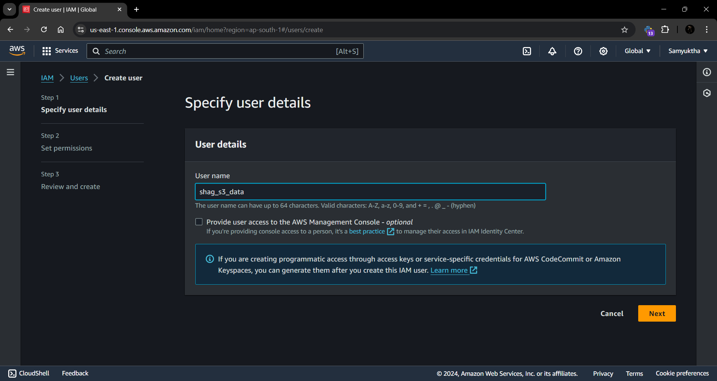

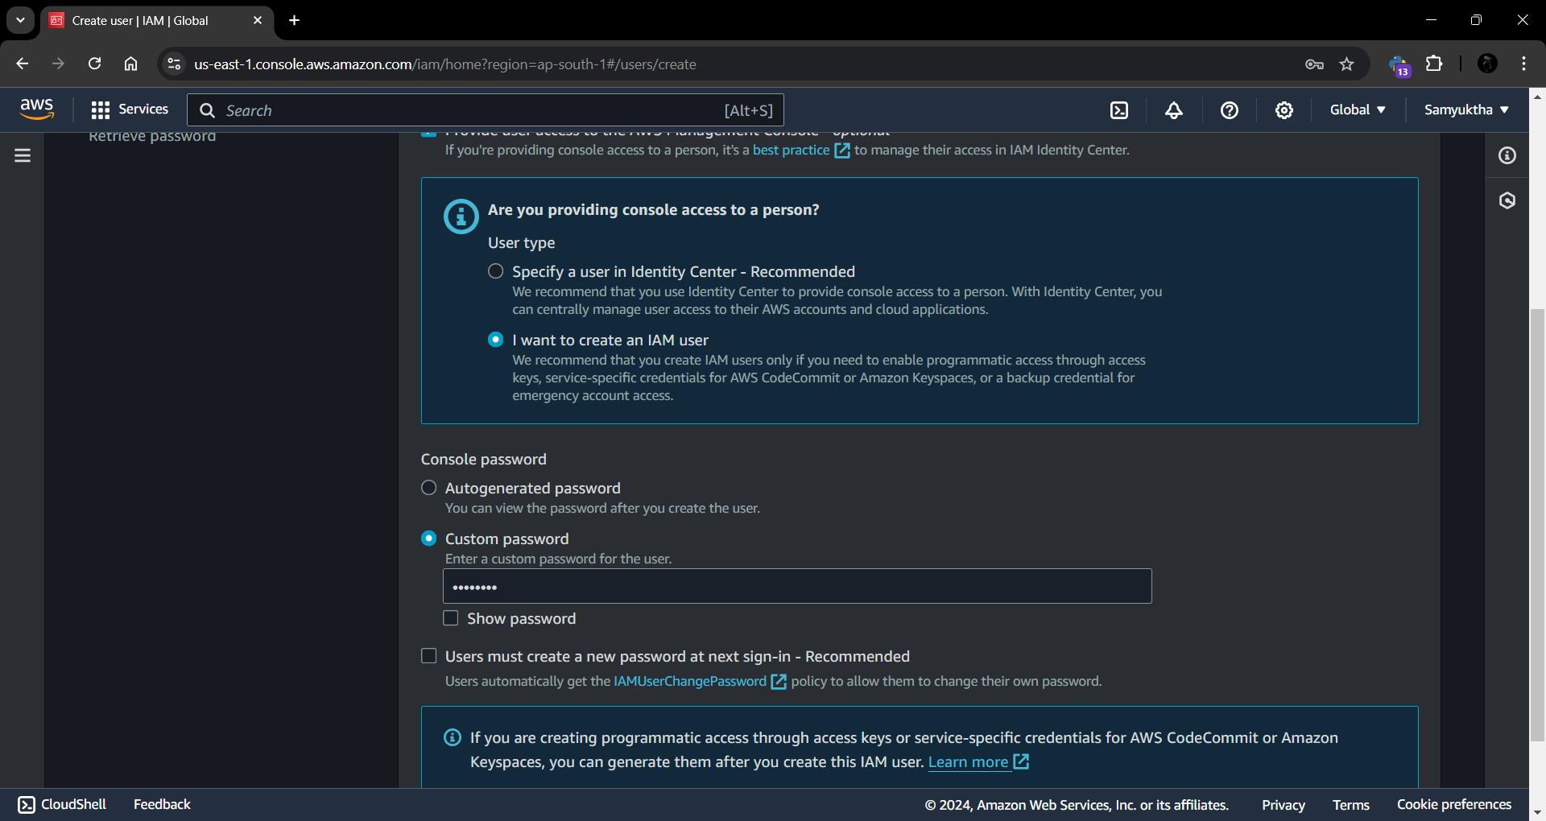

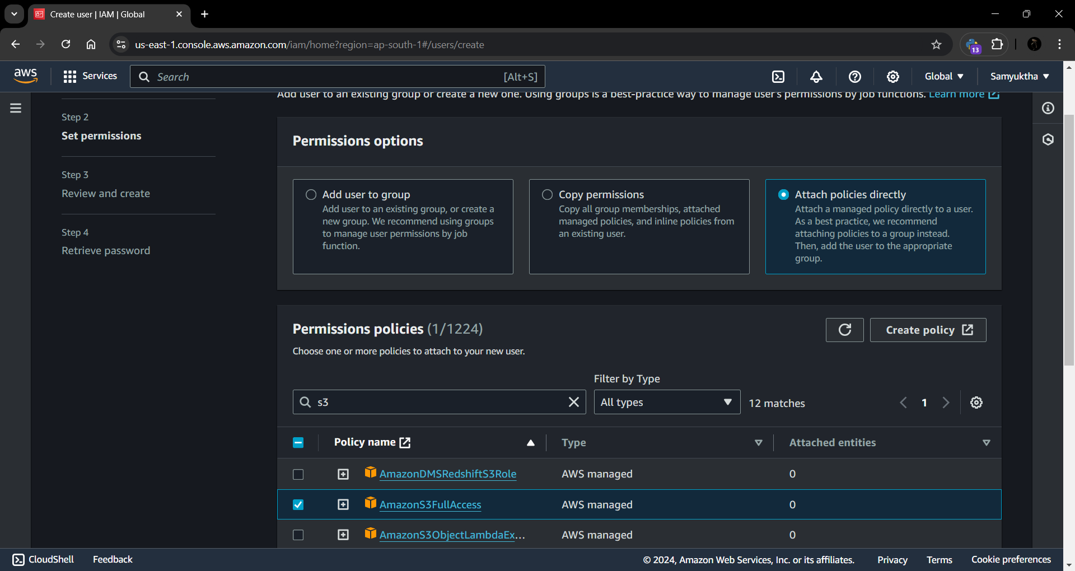

IAM User Created



